Ключи: 1, 2, 3, 4, 5, 6, 7, 8, 9, 10, 11

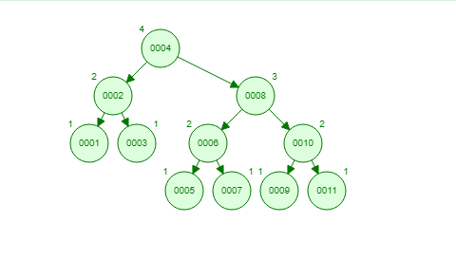

Ключи: 20, 15, 9, 18, 40, 35, 51, 27, 37, 36.

